Village of New London Lead Service Line Replacement Project
The Ohio EPA and US EPA regulate public water systems in Ohio to ensure that the water is safe and meets all primary drinking water standards. In recent years exposure to lead in drinking water has become a growing concern across the country. One of the primary ways lead enters drinking water is through lead services lines and lead service line connections. Ohio has implemented House Bill 512 and the US EPA has revised the Federal Lead and Copper Rule to require public water systems to identify lead and galvanized services and work toward replacement of the lines.

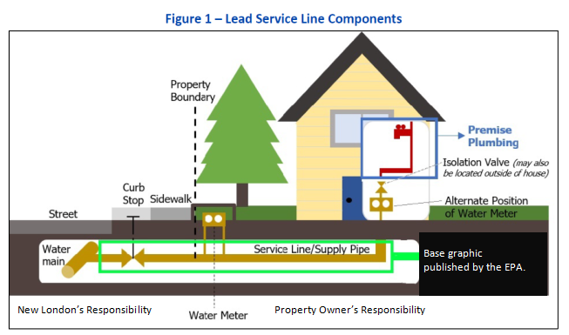
What is a Service Line?
Figure 1
A service line provides water from the Village owned water main line to the property. The water main is installed along the street in the right of way and the public (utility owned) service line connects from the water main to the property line. This is the Village of New London’s portion of the water service and our responsibility. The property owner is responsible for the private (customer-owned) service line section from the property line into the house or building. See Figure 1 for a typical service line diagram.

Lead Service Line Replacement Project
The Village of New London has previously completed in person and mail in surveys to determine the material of the public and private service lines throughout the Village. The Village is conducting a project to further investigate and verify service line materials and is planning to begin to replacement of service lines that are confirmed to be lead or galvanized pipe. Investigations of individual service lines will occur on service lines that have been identified as being most likely to be galvanized or lead material. The Village is working to secure funding to support the replacement of lead service lines once they have been identified.

Your Water is Safe for Consumption
The New London water system is in compliance with all EPA rules regarding lead service lines and is not required to perform this project. We have chosen to proceed to ensure long term compliance and safety of our customers.

Schedule
We expect service line investigations to occur during April and May of 2021. Once we have completed the investigation phase, we intend to publicly bid a contract for the replacement of the service lines. Construction for the removal of lead service lines is not expected to start before August. A typical installation will involve removing the service line from the waterline to the inside shutoff or water meter and replacing it with a new service line made of an approved material.

Will Service Line Replacements be Required?
At this time no requirements are in place for property owners to conduct work on the private side of the service line. If any portion of your service line is determined to be lead or galvanized pipe, you will be contacted by Village staff to discuss replacement options. The Village is responsible for the replacement of the public portion of the service line within the street right-of-way.

Will Service Line Replacement Lower my Risk to Exposer to Lead in Drinking Water?
Removing lead service lines reduces one of the highest risks for lead in drinking water. It is possible that other risks will remain in your house or building, including internal plumbing sources of lead. These items include but are not limited to lead solder, galvanized pipes, brass plumbing fixtures containing lead, and older faucets. A licensed plumber can be hired to identify and assist with removal and replacement of these items.

Hot water heaters also pose a risk of lead exposure in drinking water due to possible accumulation of sediment in the bottom of the tank. It is recommended that you follow the manufacturers instructions for periodic maintenance and cleaning of your water heater or consult with a licensed plumber on how to remove sediment that may have built up in the tank.
What are the Potential Health Effects of Lead Exposure?
The Ohio EPA and US EPA provide several resources describing lead in drinking water and the potential health effects that may occur due to exposure to lead. Information from the Ohio EPA may be accessed here: Learn About Lead (ohio.gov) . Information from the US EPA may be accessed here: Basic Information about Lead in Drinking Water | Ground Water and Drinking Water | US EPA . Information on additional resources can be provided by contacting the Village using the contact information below.

QUESTIONS OR CONCERNS
All questions regarding the project will be addressed by the Village, please call (419) 929-4091. The Village will also post additional information at Village Of New London - Home (newlondonohio.com).

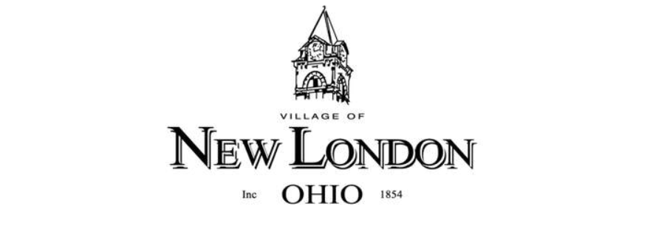
www.newlondonohio.com

